Pierre Maranda
Anthropologie, professeur d’anthropologie, Université Laval
(1989)

“An Anthropological View
of Sanctions and Rewards.”

LES CLASSIQUES DES SCIENCES SOCIALES
CHICOUTIMI, QUÉBEC
https://classiques.uqam.ca/


https://classiques.uqam.ca/

Les Classiques des sciences sociales est une bibliothèque numérique en libre accès, fondée au Cégep de Chicoutimi en 1993 et développée en coopération avec l’Université du Québec à Chicoutimi (UQÀC) de 2000 à 2024 et avec l’UQAM à partir du mois de septembre 2024.

 | 
https://classiques.uqam.ca/ | http://classiques.uqac.ca/

L’UQÀM assure depuis septembre 2024 la pérennité des Classiques des sciences sociales et son développement futur, bien sûr avec les bénévoles des Classiques des sciences sociales.

En 2023, Les Classiques des sciences sociales fêtaient leur 30e anniversaire de fondation. Une belle initiative citoyenne.

Politique d'utilisation
de la bibliothèque des Classiques

Toute reproduction et rediffusion de nos fichiers est interdite, même avec la mention de leur provenance, sans l’autorisation formelle, écrite, du fondateur des Classiques des sciences sociales, Jean-Marie Tremblay, sociologue.

Les fichiers des Classiques des sciences sociales ne peuvent sans autorisation formelle:

- être hébergés (en fichier ou page web, en totalité ou en partie) sur un serveur autre que celui des Classiques.
- servir de base de travail à un autre fichier modifié ensuite par tout autre moyen (couleur, police, mise en page, extraits, support, etc...),

Les fichiers (.html, .doc, .pdf, .rtf, .jpg, .gif) disponibles sur le site Les Classiques des sciences sociales sont la propriété des Classiques des sciences sociales, un organisme à but non lucratif composé exclusivement de bénévoles.

Ils sont disponibles pour une utilisation intellectuelle et personnelle et, en aucun cas, commerciale. Toute utilisation à des fins commerciales des fichiers sur ce site est strictement interdite et toute rediffusion est également strictement interdite.

L'accès à notre travail est libre et gratuit à tous les utilisateurs. C'est notre mission.

Jean-Marie Tremblay, sociologue
Fondateur et Président-directeur général,
LES CLASSIQUES DES SCIENCES SOCIALES.
Un document produit en version numérique par Jean-Marie Tremblay, bénévole, professeur associé, Université du Québec à Chicoutimi
Courriel: classiques.sc.soc@gmail.com
Site web pédagogique : http://jmt-sociologue.uqac.ca/
à partir du texte de :

Pierre MARANDA

“An Anthropological View of Sanctions and Rewards”.

Un article publié dans Sanctions and Rewards in the Legal System. A Multidisciplinary Aproach. Chapitre 8, pp. 156-178. Edited by M.L. Friedland. Toronto: The University of Toronto Press, 1989, 224 pp.

[Autorisation formelle accordée le 6 juillet 2005, par M. Pierre Maranda de diffuser toutes ses publications dans Les Classiques des sciences sociales.]

Courriel : pmaranda@videotron.ca

Police de caractères utilisés :

Pour le texte: Times New Roman, 14 points.
Pour les notes de bas de page : Times New Roman, 12 points.

Édition électronique réalisée avec le traitement de textes Microsoft Word 2008 pour Macintosh.

Mise en page sur papier format : LETTRE US, 8.5’’ x 11’’.

Édition numérique réalisée le 6 janvier 2025 à Chicoutimi, Québec.

Pierre Maranda
Anthropologie, professeur d’anthropologie, Université Laval

“An Anthropological View
of Sanctions and Rewards”.



Un article publié dans Sanctions and Rewards in the Legal System. A Multidisciplinary Aproach. Chapitre 8, pp. 156-178. Edited by M.L. Friedland. Toronto: The University of Toronto Press, 1989, 224 pp.

Note pour la version numérique : La numérotation entre crochets [] correspond à la pagination, en début de page, de l'édition d'origine numérisée. JMT.

Par exemple, [1] correspond au début de la page 1 de l’édition papier numérisée.

[156]

Pierre Maranda
Anthropologie, professeur d’anthropologie, Université Laval

“An Anthropological View
of Sanctions and Rewards”.

Un article publié dans Sanctions and Rewards in the Legal System. A Multidisciplinary Aproach. Chapitre 8, pp. 156-178. Edited by M.L. Friedland. Toronto: The University of Toronto Press, 1989, 224 pp.

Introduction

Many people draw a distinction between the 'natural sciences' and the 'social sciences.' Their position is that social facts cannot be approached with either the same rigour or the same brutal coolness as physical facts. Yet many long for the day when neurophysiological psychology and the social sciences will have rendered human behaviour amenable to 'real scientific treatment.' In the meantime, somewhat like quantum physicists, we keep looking for probable outcomes. Wittingly or not, we formulate hypotheses on others' responses — on the basis of previous experiences — so as to find our bearings and act properly.
Don't we think we know somebody intimately if we can predict that person's behaviour? Don't we think we fit well in our peer groups if we know what is expected of us ? Prediction, expectation, and conformity (which ensures predictability) are key terms in social interaction. We need 'rules', 'patterns', 'norms', and 'normality' so that we can define and consolidate 'regulations' and thus steer acceptable courses of action. Human beings need to know when recurrences become patterns, when patterns become acceptable, and when widely acceptable patterns are prescribed as norms. Consumers' associations, anti-smoking sentiment, sex education programs in schools: all are examples of recurrences gathering momentum to stand up as patterns that can eventually be enforced through laws. And compliance with laws yields conformity (that is, social homogeneity), which in turn allows for sound expectations, so that one can predict outcomes and feel good because of a sense of 'belonging.'
Now, that works well on the level of abstract principles, and even on [157] the grass-roots level since, as we say in anthropology, all cultures tend to be imperialistic: the members of all human societies took down upon foreigners, as they need to do in order to consolidate their self-respect. Human cultures have to offer uncontrovertible semiotic charters to their members -charters that will give people 'social contracts' enabling them to 'belong': to communicate with each other in trust, within relatively well-defined and stable parameters. Further, semiotic charters make people believe in themselves enough to think it worthwhile to reproduce themselves. And since societies exist only to reproduce themselves, laws must guarantee cultural incontrovertibility. In other words, there must be absolute taboos and prescriptions; violating the former must be punished and complying with the latter must be rewarded.
Some people, however, derive their rewards from getting away with taboo violations; by the very fact that they try to secure obedience, do societies fail to engage their 'smartest' members ? Or does that depend on types of legal systems and on the relative importance given to sanctions as opposed to rewards within a legal system ?
A jurist turned anthropologist has suggested a distinction between legal systems in technological societies and more 'human' ones. Our legal system would be characterized by codified and rigid sets of laws that are mostly repressive; that of other, simpler societies, by flexibility and fluid adaptation emphasizing rewards. (It is interesting to note that the title of this volume reflects, in its word order, the emphasis of our conception of law: first, 'Sanctions', and second, 'Rewards.) Our own system would be essentially conservative, while that of other societies would be essentially amenable to socially variable conditions (would demographers say that conservativeness is correlated with population size?). And to Pospisil's New Guinea data we can add further evidence from several cultures in Africa and elsewhere.
To be more specific: in some cultures, litigation contributes to joyful social life instead of building up tensions. The very judicial process is a reward in itself, not a grim fight. Let me quote one example, from a well-documented ethnography of the Subanum of the Philippines, where the legal process is a most convivial form of social interaction.

Litigation [in that society] cannot be fully understood if we regard it only as a means of maintaining social control. A large share, if not the majority, of legal cases deal with offenses so minor that only the fertile imagination [158] of a Subanum legal authority can magnify them into a serious threat to some person or to society in general ... A festivity without litigation is almost as unthinkable as one without drink.
In some respects a Lipay trial is more comparable to an American poker game than to our legal proceedings. It is a contest of skill ... accompanied by social merrymaking, in which the loser pays a forfeit. He pays for much the same reason we pay a poker debt: so he can play the game again ...
Along with drinking, feasting and ceremonializing, litigation provides patterned means of interaction linking the independent nuclear families of Lipay into a social unit.

We do not see trials as social feasts and we do not joke with or about the Law. Stolid citizens advocate it as the corner-stone of their stolidity. What the Subanum achieve through spirited and lively litigation processes, we aim at through solemn and severe tribunals. For us, at least in authority circles, social homogeneity is a cause to promote and consolidate. But don't our cities and even our villages comprise many subcultures, each with its own code of ethics, of etiquette, of love, of parental behaviour ? Multiculturalism, 'racial integration' policies, and minority rights go against monolithic views of society. Must we conclude, in the best relativistic tradition, 'to each its own norms' ? Is the cause of social homogeneity a delusion or even a mystification ? And shouldn't our predictions rest on a different basis from our stem conception of law ? Shouldn't we revise that basis to accord with notions of norms and expectations ? This leads us to focus on the notion of 'norm.'
This paper consists of a general and partial anthropological overview of law. The following section begins with law as a social fact, to set it in a holistic perspective; sanctions and rewards are then approached from the standpoint of social norms and inertia (conservativeness), and a sketchy statistical framework is provided for their analysis. In the third section, sanctions and rewards are cast in terms of regulation mechanisms acting on the imagination. A brief account of our correlational analysis of cardriving and sexuality is presented in the fourth section; five testable hypotheses on the topic are proposed. The final section suggests three outlooks related to legal sanctions and rewards: semiotic capital, terrorism and martyrdom, and creativity. In conclusion, the ideology of social reproduction is set in the context of the ratio of sanctions to rewards.
[159]

Law as a Social Fact

Anthropologists define 'law' as a 'social fact'. The term comes from Emile Durkheim ; British anthropologists use 'institution' for the same concept. For us, social facts are the sets of behavioural frames, resting on more or less fuzzy rationales, that a society deems essential to its perpetuation. Examples of social facts are kinship systems, monetary systems, religions, art, and politics. We consider any single social fact to be intertwined with all others in the social fabric. Consequently, our approach to law or any other social fact is 'holistic.' Sometimes this leads us to unexpected investigations: for example, in a recent study on cardrivers, we were led to take pornography into consideration. Anthropology is like landscape photography; one may focus on a component, but one cannot ignore the rest of the grounds.
All societies have regulation mechanisms. Taboos are such a mechanism: their violation entails 'metaphysical' or social sanctions. All societies have compensation mechanisms as well: the costly consequences of wrong behaviour can be neutralized through some form of expiation or redemption. Rewards also work as regulatory devices. They provide incentives. We argue that sanctions and rewards are society-specific and designed on the basis of statistical norms, and that their function is to maintain social inertia.
Social inertia is as fundamental in social life as gravity is in the physical world. Inertia maintains collective identity and enables the members of a society to predict the consequences of actions. One crosses a street when the traffic light is green on the assumption that, in all probability, cars will respect the interdiction signified by a red light and will not run pedestrians down. One can predict the results of an act of kindness, a smile, or a tantrum because social inertia has consolidated types of responses to such stimuli. Social inertia is a sort of gyroscope that keeps a society set on a given course and provides its members with mental and psychological security. It even goes as far as shaping 'common sense.' Social inertia can be defined as the commonality vector structuring the thought and behaviour of most people in a given society. In this respect, it is obviously describable in statistical terms. Social inertia carries human lives in the ruts more or less clearly marked by norms.
On the one hand, norms can be elicited from behaviour patterns. Expectations [160] are then based on 'belonging' to the peer group, to one's subculture. Norms will be situational and will result from implicit widespread consensus: a statistical inference. And a political authority that wants to be acknowledged by its subjects must consolidate those norms emerging from social pragmatics. On the other hand, norms can also be defined from the top, by being imposed by some authority — a curfew, censorship, abolition of the death penalty, whatever the authority thinks it can get away with, whatever it can impose on its subjects without being overthrown. Here, belonging will be defined as conformity to an abstract group, the homogeneous nation, or the dominant culture. Conformity to both types of norms will be required and rewarded, and deviance will be punished. And both types are teleological; that is, their function is to ensure social perpetuation.
I do not want to belabour the point; I urge readers familiar with anthropology to skip the following paragraphs, and those familiar with statistics to skip the curves that come after.
The following excerpt is from an introductory textbook in cultural anthropology that is already twenty years old. It shows what undergraduates learn in our field about norms and expectations.

The reader may well ask whether the concepts of norms and expected behavior are not identical ... A refined analysis of social organisation requires that they be logically distinguished. The status of a religious specialist in our society, a minister or a priest, will serve to illustrate this distinction. The expected behavior associated with this status includes the most exemplary conduct ... abstention from gambling and drinking, dignified demeanor, etc. However, the minister who serves a sophisticated congregation may find it necessary to keep close to his people through such devices as moderate social drinking, laughing agreeably at off-color stories ... Such behavior may actually become the norm for ministers in a given community without altering expectations of more exemplary conduct (expected behavior) ...
What is the value of this distinction? Principally, it contributes to understanding social organization as a dynamic process. Social structure would be a static concept without the essential ingredient, action. Real action departs from expected action for any status or structural position in a society. Such departure, however, is never a disorganized or haphazard process. Even the departures occur within specified limits and may become [161] normative in themselves. Thus, in the example above, ministers or priests may behave closely in accordance with community expectations. In this case, the norms and the expected behavior will be nearly congruent or coincidental. Where social factors favor a more relaxed attitude on the part of the clergy, expectation action and normative action will diverge. But clergymen will, under these circumstances, tend to depart from expected behavior in similar directions, thereby establishing a new pattern or norm. This is one way in which new norms come into being: when actual behavior shows a general shift away from an established pattern. Such a process goes on continuously in any society. Isolating the cause for such shifts is an important part of the study of culture change.

A Sketchy Statistical Framework

Let me illustrate this anthropological view with some basic statistical representations. They are purposely simplistic, in order to make the point unambiguously.
The following curves sketch profiles of compliance, with the horizontal axis representing degree of compliance, and the vertical axis representing the number of persons that comply more (+ tail) or less (- tail).
Curve 1 represents a 'tightly knit' society, such as Quebec before the Quiet Revolution ; here, inertia is very high, and there is only one dominant culture (imposed from above, in the case of pre-1960 Quebec, through the collusion of church and state). Curve 2 depicts a 'loosely knit' society, one that is more tolerant and less monolithic than that represented by curve i. Here, inertia is low. Curve 3 shows a society on its way to a major split: it is pulled apart by two competing polarities. In that case, inertia is polarized by two different vectors. Established authority is in conflict with a subculture that has gathered momentum to the point of 'establishing a new pattern or norm,' in Schwartz and Ewald's terms. A curve 2 society may be on its way either to type 1 from type 3 or to type 3 from type 1, depending on inertia dynamics — that is, the interplay of centrifugal and centripetal forces.
For the sake of these illustrations, let us divide the curve into three segments, a main area and two tails. The main area gives the profile of the majority. Its shape is indicative of the degree of solidarity. A flattened curve depicts diffuse solidarity. In contrast, in a curve like the first one, social solidarity is intense; average, means, and mode coincide. In a [162] curve like the third one, the two modes signify a lack of solidarity. Divisive factors are such that means and average are mental constructs rather than adequate factual representations.

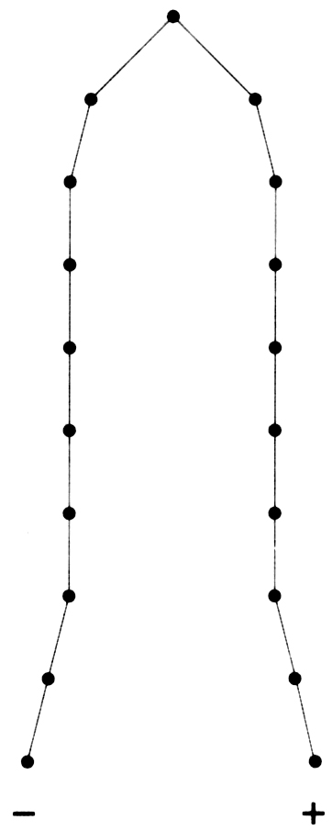
Curve 1. A tightly knit society

We will label the right-hand tail 'positive'. There stand the people who are the supreme embodiments of social ideals — heroes, saints, martyrs, charismatic leaders. At the left-hand tail of the curve are found supremely deviant people: assassins, rapists, terrorists, dictators — whatever types of deviants are deemed the most reprehensible in a given society.
The overwhelming majority of the members of the society represented by curve i gather around similar values; their opinions and behaviour are stereotyped; they tend to be submissive, intolerant, selfrighteous, law-abiding, and severely punitive of deviants. In this type of society, there is almost no room for normal standard deviation: it would take very strenuous efforts to pull away from the pack. Only simple categories of exceptionality are possible: outcasts and saints. Sanctions and rewards will be equally drastic and fundamental — for
[163]

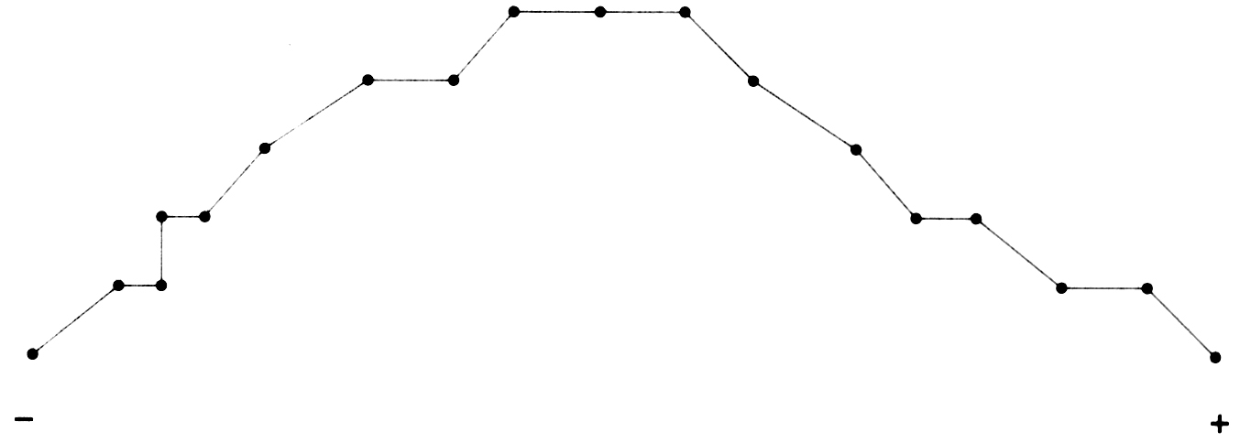
Curve 2. A loosely knit society

example, the death penalty as well as canonization will be regular enforcement mechanisms.
A society whose profile could be represented by curve 2 is much more permissive than those sketched in curves 1 and 3. It is not strongly homogeneous; it is relatively easy for people to move out of the centre of inertia to the tails of the curve. Both sanctions and rewards will be moderate — the death penalty as well as canonization will be avoided. As the number of people may accrue toward one or the other tail, however, the society may evolve in one direction (toward generalized compliance), in the other direction (toward generalized dysfunction), or in both directions at the same time. Curve 2.1 shows a move toward generalized compliance; curve 2.2 shows a move toward social rebellion. Curve 3 sketches the result of a move in both directions, which may result in a deep social split yielding two subsocieties, each of the type represented in curve 1.
Curve 2.1 is skewed toward the right. It means that most of the population it represents is much closer to the positive tail than to the negative tail; it is the curve of a population of strongly law-abiding citizens. Its long negative tail indicates that the population also comprises a much higher component of deviants than the population represented by curve 1.
In curve 2.2, the left-skewedness indicates a society in which a majority is reluctant to abide by its leaders' decisions. Whereas curve 2.1 is typical of people 'pulled forward' by a common incentive, curve 2.2 is a display [164] of people 'held back' near the negative tail end, by inertia, lack of adhesion, or lack of commitment. This type of society could be dominated by some form of tyrannical or dictatorial power consolidated mainly by fear or indifference.

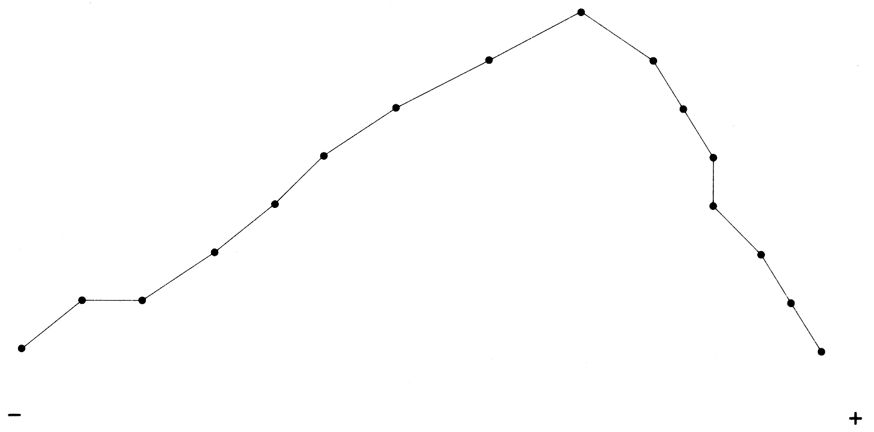
Curve 2.1. A society moving toward conservative solidarity

In curve 3, we have a bi-modal curve; that is, a curve with two equally important peaks. People in the valley between the two peaks are at the same time situated on the negative tail of mode A and on the positive tail of mode B. Their 'schizophrenic' status will become more and more excruciating as the pull increases toward social split. But should centripetal force become powerful enough, (+) and (-) would be resorbed gradually, the mean and the average would shift to the right or to the left, and the curve would become similar to curve 2.1 or curve 2.2.

Sanctions and Rewards:
The Major Regulation Mechanisms of Inertia

The two main regulation mechanisms of inertia are fear and seduction. Both operate on imagination as the faculté of anticipation. The threshold of fear is relatively low, that of seduction much higher. In other words, a little fear goes a long way toward affecting people's behaviour, but it takes a lot of seduction power to achieve the same results. This facility [165] of fear may be the reason our legal system relies more heavily on sanctions than on rewards.

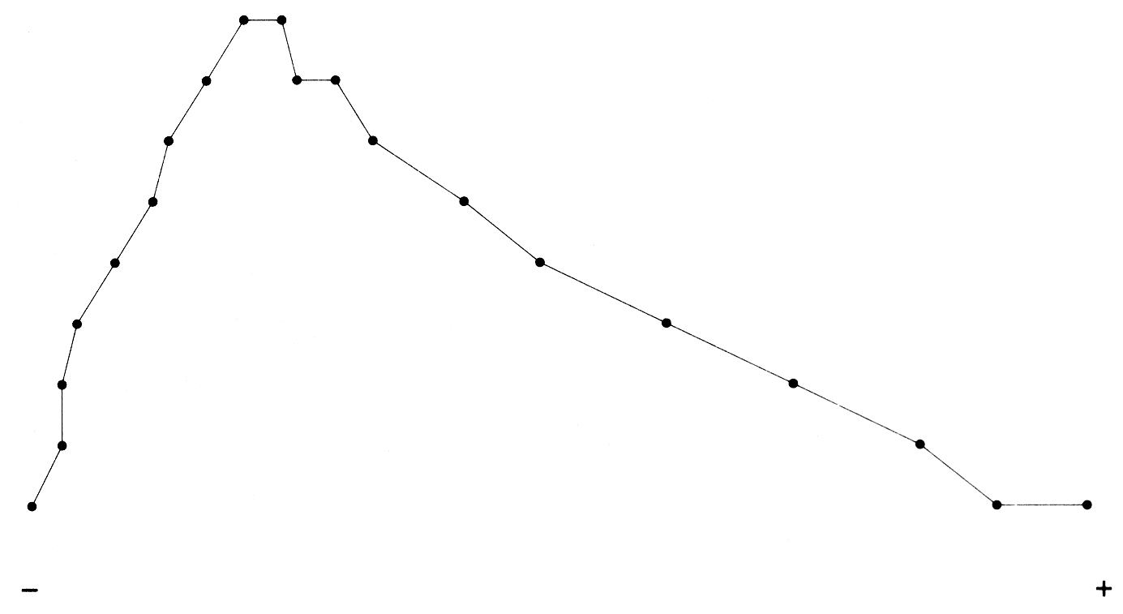
Curve 2.2. A society moving toward social rebellion

Fear and seduction thresholds can be measured. On the basis of studies in communication and marketing, ) we can state that the impact of fear on a person or group will have to be around 10 per cent of the system's inertia' to be effective as a factor of change. Seduction will have to score about 40 per cent to 50 per cent on the same scale to trigger a response strong enough to override inertia. Think of marriage stability motivated by fear of divorce; of anxiety motivations underlying investments in insurance policies versus investments in the stock market; of brand loyalty; of the results of Quebec's sovereignty-association referendum; and of the semiosis of marketing on the whole. Psychography, semiography, and applied semiotics provide tools for quantifying these momenta.
In comparative studies of the people of Quebec City's Upper and Lower Town, we were able to pin-point differential vulnerabilities. Through the collection of data with specialized protocols, we produced semiographies, on the basis of which we could build probabilistic models of inertia and of the differential effects of threats and rewards on the two populations. We were able to show that inertia and fear are typical of family-centred people (the 'private man'), and innovative behaviour and [166] quests for rewards are typical of career-oriented people (the 'social man').

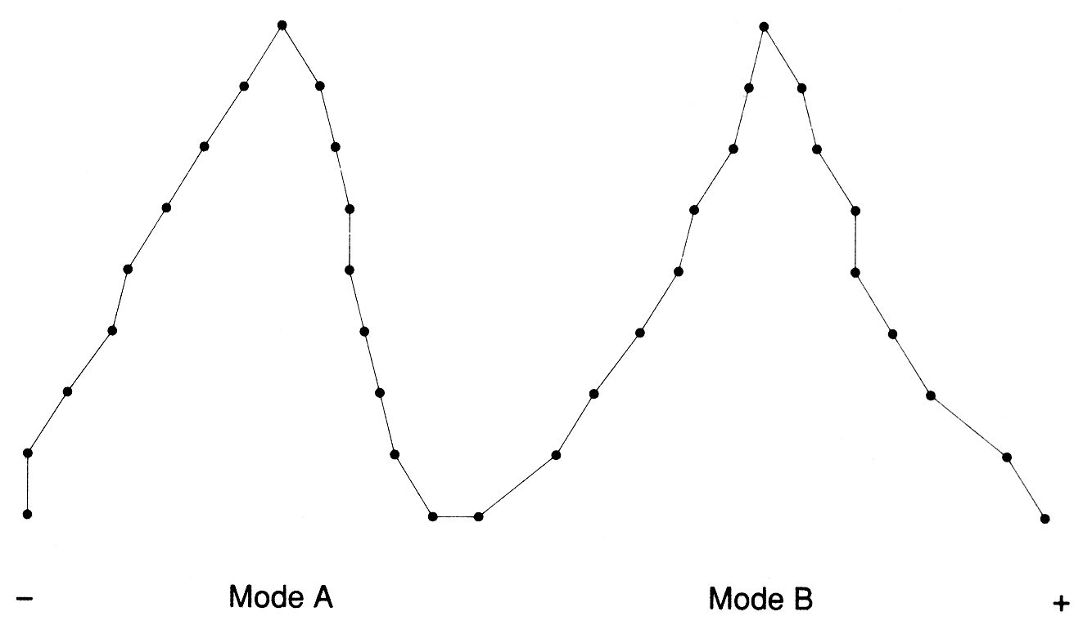
Curve 3. A strongly polarized society

Accident-Proneness and Pornography

Recently, we conducted a study of the three 'pornographic' magazines with the highest sales in Canada: Penthouse, Playboy, and Hustler. (I use the word 'pornographic' to mean 'sexually explicit' but not necessarily illegal.) In the framework of a previous study of male car drivers between eighteen and twenty-five years of age, we had been led to consider a correlation between the use of pornography and driving behaviour. We found corroboration of the hypothesis that men tend to 'metaphorize' vehicles as women. Both provide 'trips.' And one can infer accident-proneness, among young male drivers, from the way they view women; correlatively, one can infer the type of pornography consumed from driving styles. Why are these two dimensions related ? A brief general semiotic exposition is required to answer the question.
[167]

Cars and Mates

One may go as far back as The Song of Songs in the Bible, where a woman is compared to 'a mare of Pharaoh's chariots.' Women have long been 'metaphorized' as horses in our western symbolic systems. Then cars came along and superseded horses. A carry-over took place — that is, a transduction along a semiotic inertia vector. A new thing (car) fulfilling an old function (transportation) is named after the former signifier; car engines are rated by their 'horsepower.' Transduction inspires many car-makers when they give names to their products: Mustang, Bronco, Pinto, Pony. And a maker's fleet of Formula i racing cars is called his 'stable.'
Cars, the new 'horses,' have kept the latter's signifier value: they can be used as an idiom to 'metaphorize' women. In other words, a newly derived signifier became available for an ancient signified. Figures 1 and 2 illustrate this.
The French semiotician Roland Barthes, and the exuberant and tremendously popular French writer of pseudo-mystery stories, San-Antonio, both commented in the same terms on the Citroën DS, pronounced 'déesse,' or 'goddess'. The automobile is the modem man's goddess. Indeed, the young drivers in the random sample tended to structure the connotations of women and of cars along the same semiotic vectors. Our sample was divided into two groups of 100 male drivers each, ranging in age from eighteen to twenty1five; all were products of the same general social conditions. Group 1 had had car accidents while driving, and group 2 had had none. A combination of Word Association Tests and Plot Association Tests was used to elicit connotations of three stimuli ('automobile,' 'woman,' 'man') and to have the respondents invent a story with the same three stimuli.
Drivers who had had no accidents predicated the same attributes of their women and of their cars: trustworthy, reliable, thrifty, very dependable though somewhat sedate and slow in responding, and requiring good care. Those young men already saw themselves as socially established fathers, responsible citizens whose lives gravitated toward a domestic pole. In fact, their self-images were those of men approximately ten to fifteen years older.
[168]
Drivers who had had accidents also predicated the same attributes of their women and of their cars, but the attributes differed from those of the other group. Both 'instruments of pleasure' had to be exciting, challenging, dashing. They were to be given little care, yet must be flashy. They had 'nerve' and quick responses, and they could 'drive you nuts' in the positive sense of the idiom. Immediacy of pleasure and short-time orientation were strong components of those connotations by accidentprone drivers, who did not share in the long-term visions of themselves specific to the group 1 subjects.

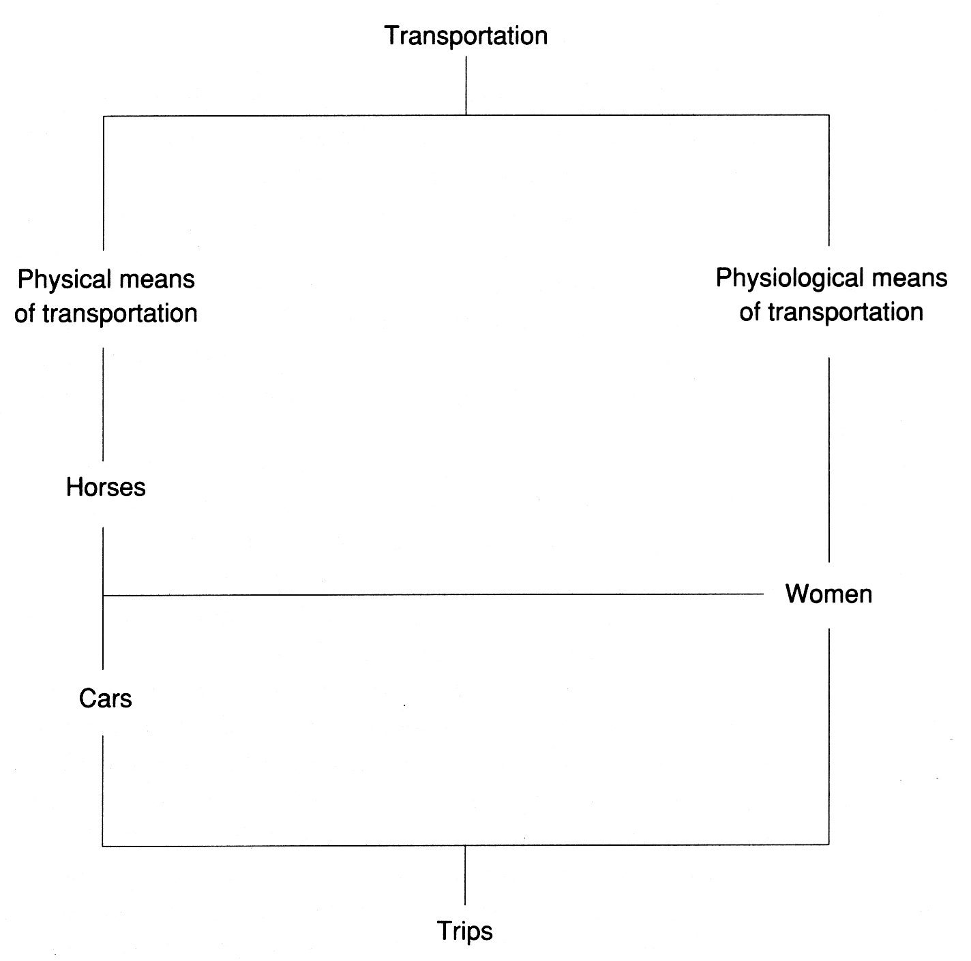
Figure I. Horses, cars, and women: semiotic transduction

[169]

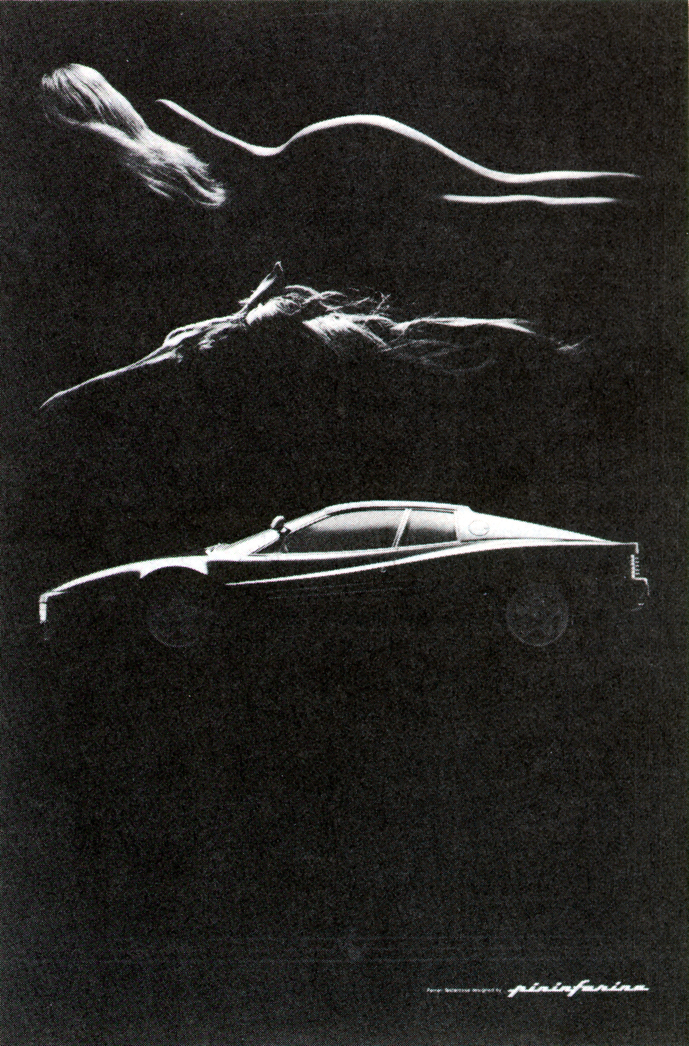
Figure 2. Horses, cars, and women
Reprinted with permission of Road & Track magazine
[170]

Driving and Pornography

What, then, of pornographic magazines? The least pornographic of the three publications analysed was Playboy. It was also the one in which there were the most car advertisements: The most pornographic magazine in the sample, Hustler, contained no car advertisements at all. Penthouse fell in between. An interesting correlation: the pornographic contents of Playboy increased over the last twenty years; congruently, the number of car advertisements went up, from an average of two per issue in 1965 to an average of eight in 1985 (with a peak of fifteen in 1980). But the increase in pornographic content lagged considerably behind that of Penthouse and Hustler.
The types of cars advertised in Playboy were mostly of the middlerange variety, with occasional trends toward higher-performance models but very seldom approaching the true sports machines. Playboy's cars remained sedate, like its bunnies. It was a magazine for dreamers (and safe drivers) rather than doers. In contrast, Penthouse featured motorcycles. And although Playboy occasionally advertised radar-detectors, it did so in the ratio of 0.25 to car advertisements; Penthouse's ratio was 1.8 times. In other words, the ratio of car to radar-detector advertisements was 7.2 times higher in Penthouse than in Playboy, and Penthouse was clearly more pornographic than Playboy. Is it significant that Hustler published neither car nor radar detector advertisements?
To tackle the issue from a slightly different angle: safe drivers will buy Playboy; they will look for mild excitement — soft-core porn and sedate cars. Risk-prone drivers will buy Penthouse, and they seem to offer a better market than Playboy readers for radar-detectors. They want more than allusions, more than just convenient performance. Hustler's readers do not 'metaphorize' women into cars, or vice-versa: the ads in the magazine are for all sorts of sex gadgets. Whereas the readers of the two other magazines fantasize and metaphorize, Hustler's readers seem to have no need for figurative meaning; they want the thing itself, in its literal meaning.
Of course, our examination of car-driving and pornography still leaves a great many issues unexplored. Like all studies, it ends with more questions than answers. So far, the limited data enable us only to suggest such hypotheses as the following five. (Remember that only males between the ages of eighteen and twenty-five are under consideration.)
[171]

Hypotheses on Relationships between Driving and Sexuality

1. An active sex life correlates positively with low accident rates. In Quebec City, ten regular patrons (average age: 30-47 years) of an Upper Town brothel do not consume pornography ('Why would we? We've got the real thing!' they said in answer to our questions), and they have had fewer car accidents than consumers of pornography.
2. The use of hard-core pornography correlates positively with high accident rates. Hard-core pornography consumers are more prone to car accidents than soft-core pornography consumers. These consumers tend to be doers rather than dreamers. They tend to take risks, sometimes only for the sake of risk. They like to live dangerously, to take chances. Their driving behaviour is congruent with their general attitude to life. Their psychodynamics are stereotyped by images of forcefulness, power, challenge, domination, prestige, and the need to succeed.
3. The use of soft-core pornography correlates positively with average accident rates. Soft-core pornography consumers are dreamers rather than doers; they live more in imagination than in reality: their imagination constitutes a kind of buffer-zone that enables them to distance themselves from stress and frustrations. Since they compensate in imagination rather than in fact, they are less aggressive than hard-core pornography consumers, who need action more than dreams and who compensate in ways that may be aggressive.
4. Abstention from pornography correlates positively with high accident rates. Consumers of soft-core pornography might be less prone to car accidents than non-consumers because the latter are more timid and subject to greater stress without escape mechanisms; they would accordingly be less sure of themselves and more prone to erratic driving.
5. The efficacy of publicity for safe driving correlates positively with the skilful use of images of women. When life-size cardboard or plastic 'policemen' are set up by the roadside in Italy, they arouse fear in drivers. In Belgium, there are large posters showing a shapely woman admonishing drivers that 'fast driving is as stupid as fast love-making'; they are a form of seduction. My hypothesis is that of these two deterrents, the poster of the woman has proved more effective in the long term and has exerted a stronger influence.
[172]

Risk Behaviour and Marginality

Radar-detectors, motorcycles, and hard-core pornography are popular among risky drivers; safe drivers prefer sedate cars and soft-core pornography. The former are hard on their women and on their cars; the latter are soft on both. Isn't the idea of radar-detectors analogous to the mental device used by a spouse having a secret affair ? To that of a taxpayer trying to outsmart Revenue Canada? To that used by anybody who wishes to overstate his personality through some form of marginalization ? Think also of the lengths to which some individuals will go to assert themselves in their fashions, and think of all common forms of boasting.
Inertia is important to many because it offers a strong security factor. But the desire to belong may be in conflict with inertia, as may the need to assert oneself. Most people adjust their aspirations and imagination so as to experience a 'goodness of fit,' to use a statistical metaphor, which will enable them to merge with the majority of the group in which they seek or wish to keep membership. Those people will go as far as to buy Playboy but not Penthouse, let alone Hustler. There are people positioned near the 'negative' end of the curve — that of non-conformity — who will do as much as possible to escape from the 'pack': their ambition is not to fit in; they want to feel creative. In order to achieve such a state of grace, they opt for marginality. Narcotics, 'trips,' and 'speeding' in all forms provide them with the feeling of living intensely. Those ways of being actually promise and often give them vertigo, which Caillois viewed as related to the experience of the sacred, and which young children attain by spinning around until they collapse, or by riding on faster and faster merry-go-rounds in amusement parks.

Three Outlooks on Sanctions and Rewards

Semiotic Capital and Inertia

Inertia level is determined (1) by the 'semiotic capital' or 'mental stocks' owned by individuals and societies alike, and (2) by their management strategies ('network density' and 'channel capacity', or multiplexing power). Sanctions and fear will have a much greater effect on people with fewer resources; conversely, rewards will have more impact on people with greater resources, who are less easily threatened — for example, white-collar crooks. In this context, it is worth mentioning the [173] profound modification of Quebec society engineered by the former finance minister Jacques Parizeau through his REAQ program : seduction power has overriden traditional fear for over 500,000 Quebecois. Instead of investing in personal insurance out of fear, as they used to do, they are now putting their money into the stock market because the rewards have reached an economic level that allows them to recover substantial amounts of the income tax deducted at source from their pay-cheques.

Terrorism and Martyrdom

Terrorism acts on fear, and is based on a kind of reward that is akin to political 'power trips': a very small group of people can threaten a whole nation. In this respect, terrorism can be seen to be related to martyrdom, in which people put themselves in such a position that punishment (by their societies' enemies) will be their ultimate reward. Both are forms of 'heroism,' which is in turn a form of marginalization: to carve for oneself a place in the tail of a normal distribution curve is a stimulating, rewarding endeavour.

Deviation and Creativity

McLuhan has defined creativity as 'whatever one can get away with' — and this applies to deviant behaviour as well as to poetry or music. Law-making and law enforcement face this 'creativity problem.' Will innovative trends prevail over conservative forces ? How much mafia can a social system tolerate without collapsing ? This goes back to the types of social dynamics illustrated by the curves earlier in this paper. Marginalization and creativity are rewards in themselves. They provide vertigo. In order to be creative, a legal system has to offer positive incentives that outweigh sanctions; to offer only inertia consolidation through sanctions might be enough for the rank and file, but this is tantamount to underestimating one's own fellow citizens and is akin to 61itist and oligarchic philosophies of authority.

Conclusion: Law and Social Reproduction

The preservation of social identity is necessary for people to have personal identities — this was Althusser's classical contribution to the analysis of appareils d'État. To paraphrase him: a society's inertia can call people [174] by their names because it has given them their names. The French anthropologist Augé has developed the thesis; what he calls the 'ideologic' of a society is its semiotic charter, in which people inscribe and save their identities. Sanctions and rewards play a fundamental role in that preservation process.
But what are the grounds of that process ? We say that human societies, like animal species, exist only to perpetuate themselves. The difference between us and other mammals is that we have 'culture' — a deliberate mechanism to ensure 'pro-creation' (social reproduction), an essential part of which is a set of values implemented through a program of sanctions and rewards. We punish those who undermine our self-confidence and reward those who enable us to consolidate our power and social comfort. We can thus believe that our society is worth perpetuating.
The legal systems of technological societies are more repressive — that is, conservative and inert — than productive of creativity. Could the ratio of inertia to creativity be changed ? Could our legislators and judges look forward instead of walking backward like lobsters? The answer is clearly yes. It is a question — a major one — of restructuring our conception of law to centre on rewards rather than sanctions. This is a task for semiotic engineering, for it implies revamping mentalities. Could we hope for such a conversion? Could we aim at operating mentally and emotionally like Malinowski's Trobrianders ? Can we envisage, and work for, a new society in which enthusiasm would override meanness, and where it would be so rewarding to dwell that sanctions would become a rarity ? Optimistically, yes.
Think of what Parizeau did recently to traditional Quebec business pusillanimity and inertia with the REAQ legislation. Is it not time to reexamine our conception of law and to act on the basis of a creative rather than a repressive model? For example, could not the car insurers return, but much more boldly, to the incentives (too timid in the past) of lowering premiums for good drivers ? Rates would go down, year after year and substantially, for drivers who were accident-free over a continuous period, and they would increase substantially with each accident for other drivers. Of course, insurance companies would make less money. But should the rationale of legislation be based on the profitability of insurance companies ?
When we learn to use rewards (positive incentives) rather than sanctions (fear and deterrents), we will have come a long way toward a much more dynamic and productive society, a society that will want to reproduce [175] itself for better reasons than just inertia. We can envisage a nation in which law would be inspiring and ahead of the times instead of being stifling and trying clumsily to catch up with events generated by imaginative freaks.

NOTES

Pour faciliter la consultation des notes en fin de textes, nous les avons toutes converties, dans cette édition numérique des Classiques des sciences sociales, en notes de bas de page. JMT.

[176]
[177]
[178]
Fin du texte

See C. Lévi-Strauss, La Pensée Sauvage (1962) 118-119, 220. https://monoskop.org/File:L%C3%A9vi_Strauss_Claude_La_Pensee_sauvage_1962.pdf
A semiotic charter is a set of implicit propositions (some anthropologists, like Hoebel, call them 'cultural axioms') providing common semantic grounds to the members of a society. Those common semantic grounds are interpretation grids, and they are shaped in clichés, proverbs, sayings, stereotypes, prejudices, and postulates, as expressed in folk-tales, popular songs, religious beliefs, novels, films, etc. A semiotic charter is generally acquired through enculturation during childhood and is more or less consolidated over the years. Such charters enable people to have the impression that they understand each other when they communicate. Semiotic charters are culture-specific and form the basis of 'common' sense. Their basic components and dynamics can be analysed by semiography (see infra note 13).
L. Pospisil, 'Law and Order,' in J.A. Clifton (ed), Introduction to Cultural Anthropology (1968), 201.
Witness an unimpeachable authority in ethnography, B. Malinowski; he commented as follows on 'law' in Trobriand society: 'Here we come at last to the most important point — there exists a class of binding rules which control most aspects of tribal life, which regulate personal relations ... There is no religious sanction to these rules, no fear, superstitious or rational, enforces them, no tribal punishment visits their breach, nor even the stigma of public opinion or moral blame ... The binding forces of Melanesian civil law are to be found in the concatenation of the obligations, in the fact that they are arranged into chains of mutual services, a give and take extending over long periods of time and covering wide aspects of interest and activity. To this there is added the conspicuous and ceremonial manner in which most of the legal obligations have to be discharged. This binds people by an appeal to their vanity and self-regard, to their love of self-enhancement by display. Thus the binding force of these rules is due to the natural mental trend of self-interest, ambition and vanity, set into play by a special social mechanism into which the obligatory actions are framed' (Malinowski, Crime and Custom in Savage Society [1961] 66-67; see also 31-32). Another British anthropologist, M. Gluckman, objected to Malinowski's use of the term 'civil law' to cover 'the mechanisms of social control which operate positively to induce people to fulfil their obligations': Gluckman, Politics, Law and Ritual in Tribal Society (1965) 205; see also 196-206. In contrast, the American sociologist-cum-anthropologist G. Homans readily used the notion of 'control through effective integration' to account for similar mechanisms: Homans, The Human Group (1950) 288.
For evidence on Africa, see, for example, John Mensah Sarbah, Fanti Customarv Laws (1968) 22; Max Gluckman, The Judicial Process among the Barotse of Northern Rhodesia (1955) 350 ; and John Beattie, Bunyoro, an African Kingdom (1960).
C.O. Frake, 'Litigation in Lipay: A Study in Subanum Law', in Proceedings of the Ninth Pacific Science Congress of the Pacific Science Association (Bangkok 1963) 3: 221.
See Sociology and Philosophy (1953), a collection of Durkheim's later essays (at 24) and his essay 'Value Judgments and Judgments of Reality' in the same volume (at 80-97).
B.M. Schwartz and R.H. Ewald, Culture and Society: An Introduction to Cultural Anthropology (1968) 189-190.
M. Rioux, La Question du Quebec (1969). https://www.classiques.uqam.ca/contemporains/rioux_marcel/question_du_quebec/question.html
For example, O.E. Klapp, Opening and Closing: Strategies of Information Adaptation in Society (1978), and C. Cossette, Les Images Demaquillées. (1985)
System inertia is measured through applications of digraph theory and probabilistic network analysis. Along related lines, on the basis of information theory, Klapp (supra note 10) distinguishes between positive inertia and negative inertia — in his terminology, 'good' versus 'bad' redundancy. The former maintains social stability and consolidates a semiotic charter; it also provides some immunity against fear and is more readily open to seduction. The latter does the opposite. This is not the place to enter into an exposition and discussion of marketing techniques, psychography, applications of communication theory, and related contributions to the understanding of social facts. It is enough to mention that the figures given rest on empirical case studies — unpublished analyses of voting intentions at the time of the Quebec referendum — and on theoretical derivations from information theory on the amount of information one can process without threat ('channel capacity').
See P. Maranda, 'Sémantographie du domaine "travail" dans la haute-ville et dans la basse-ville de Québec' (1978) 20, Anthropologica, 249.
'Semiography' is the name of a set of technical tools for the operational description of meaning and of its generative matrices; see P. Maranda, 'Semiography and Artificial Intelligence' (1985) 1 Toronto International Spectrum i. Our approach rests on dynamic network theory. It consists in identifying major images, symbols, or 'concepts' in a population by eliciting the bundles of connotations that give them effective meaning; then, by measuring their diffraction and condensation properties in a network, a 'map' can be sketched of the main constituents of a 'mentality.' Social inertia is a function of semiographic network density. The higher the number of interrelations between the nodes of a network, the stabler the network will be and, consequently, the less open to change. The types of rewards and sanctions that will be effective on a given population will be a function of the types of nodes as well as of network density — that is, of the 'notions' whose connotations are mapped in the network and on the interrelationships between those notions.
Our sample included three issues a year, every five years from either 1965 (for Playboy) or from the first year of publication for the other two magazines. See P. Maranda, Analyse de contenu et de discours des trois revues à caractère sexuel les plus répandues au Canada (Ottawa: Ministry of Justice 1986).
P. Maranda, Connotations de l’automobile chez un échantillon de jeunes Québécois (Québec: Régie de l’Assurance Automobile du Québec, 1985)
R. Barthes, Mythologies (1973) 88-90.
P. Maranda, Introduction to Anthropology: A Self-Guide (1974) book 10.
The protocol comprised several additional steps: see Maranda, supra note 15, for details.
In our sample, 1980 magazine issues do not advertise radar-detectors. The figures are only for the issues contained in the sample slice of 1985.
For field observations of faulty driving in Quebec City, see J. Hcrickx, 'Les Manoeuvres des Conducteurs Québécois' (1986) 3 Repères (Régie de l'Assurance Automobile du Québec) 2.
Ibid. 3
One might suggest, to increase efficiency and achieve still deeper conditioning, the addition of two more posters. They would both still feature the same shapely woman, The first one's caption would read: 'Are you a competent lover ?' and the text of the last of the three would be: 'Answer: look at your speedometer!'
R. Caillois, Les Jeux et les Hommes — Le Masque et le Vertige (1967)
These strategies rest effectively on operating conditions such as 'network density' — which means the ratio of actual connections between things over the number of possible connections, 'channel capacity' means the actual quantity of information that can be conveyed through one channel (the mind of a person, a telephone line, a telegram) without being garbled; 'multiplexing power' adds to 'channel capacity' the notion of parallel transmission of different sets of data without function entropy.
REAQ stands for Régime d'Épargne Actions du Québec (Quebec Stock Savings Plan). The program enables residents of Quebec to deduct from their income, for income tax purposes, sums they invest in corporations whose headquarters are in the province. The scheme has had a momentous impact on Quebec mentality. It can be seen as a second phase in the opening of traditional 'peasant economics' to the monetary system and risk-taking.
For related observations, see M. Augé. Pouvoirs de Vie, Pouvoirs de Mort (1977).
M. McLuhan and Quentin Fiore, The Medium Is the Massage (1967) [unpaginated]
L. Althusser, 'Idéologie et Appareils Idéologiques d'État' (1971) 151, La Pensée, 3. https://classiques.uqam.ca/contemporains/althusser_louis/ideologie_et_AIE/ideologie_et_AIE.html
See Augé. supra note 26.

