Pierre Maranda
Anthropologie, retraité de l’enseignement, Université Laval
(1985)

“Myths: theologies
and theoretical physics.”

LES CLASSIQUES DES SCIENCES SOCIALES
CHICOUTIMI, QUÉBEC
https://classiques.uqam.ca/


https://classiques.uqam.ca/

Les Classiques des sciences sociales est une bibliothèque numérique en libre accès, fondée au Cégep de Chicoutimi en 1993 et développée en coopération avec l’Université du Québec à Chicoutimi (UQÀC) de 2000 à 2024 et avec l’UQAM à partir du mois de septembre 2024.

 | 
https://classiques.uqam.ca/ | http://classiques.uqac.ca/

L’UQÀM assure depuis septembre 2024 la pérennité des Classiques des sciences sociales et son développement futur, bien sûr avec les bénévoles des Classiques des sciences sociales.

En 2023, Les Classiques des sciences sociales fêtaient leur 30e anniversaire de fondation. Une belle initiative citoyenne.

Politique d'utilisation
de la bibliothèque des Classiques

Toute reproduction et rediffusion de nos fichiers est interdite, même avec la mention de leur provenance, sans l’autorisation formelle, écrite, du fondateur des Classiques des sciences sociales, Jean-Marie Tremblay, sociologue.

Les fichiers des Classiques des sciences sociales ne peuvent sans autorisation formelle:

- être hébergés (en fichier ou page web, en totalité ou en partie) sur un serveur autre que celui des Classiques.
- servir de base de travail à un autre fichier modifié ensuite par tout autre moyen (couleur, police, mise en page, extraits, support, etc...),

Les fichiers (.html, .doc, .pdf, .rtf, .jpg, .gif) disponibles sur le site Les Classiques des sciences sociales sont la propriété des Classiques des sciences sociales, un organisme à but non lucratif composé exclusivement de bénévoles.

Ils sont disponibles pour une utilisation intellectuelle et personnelle et, en aucun cas, commerciale. Toute utilisation à des fins commerciales des fichiers sur ce site est strictement interdite et toute rediffusion est également strictement interdite.

L'accès à notre travail est libre et gratuit à tous les utilisateurs. C'est notre mission.

Jean-Marie Tremblay, sociologue
Fondateur et Président-directeur général,
LES CLASSIQUES DES SCIENCES SOCIALES.
Un document produit en version numérique par Jean-Marie Tremblay, bénévole, professeur associé, Université du Québec à Chicoutimi
Courriel: classiques.sc.soc@gmail.com
Site web pédagogique : http://jmt-sociologue.uqac.ca/
à partir du texte de :

Pierre MARANDA

“Myths: theologies and theoretical physics.”

Un article publié dans l'ouvrage sous la direction de Teun A. van Dijk (ed.) intitulé : Discourse and Literature. New approaches to the Analysis of Literary Genres, pp. 187-197. Amsterdam / Philadelphia ; John Benjamins Publishing Co., 1985. Collection : Critical Theory Series, vol. 3.

[Autorisation formelle accordée le 6 juillet 2005, par M. Pierre Maranda de diffuser toutes ses publications dans Les Classiques des sciences sociales.]

Courriel : pmaranda@videotron.ca

Police de caractères utilisés :

Pour le texte: Times New Roman, 14 points.
Pour les notes de bas de page : Times New Roman, 12 points.

Édition électronique réalisée avec le traitement de textes Microsoft Word 2008 pour Macintosh.

Mise en page sur papier format : LETTRE US, 8.5’’ x 11’’.

Édition numérique réalisée le 5 janvier 2025 à Chicoutimi, Québec.

Pierre Maranda
Anthropologie, retraité de l’enseignement, Université Laval

“Myths: theologies and theoretical physics.”

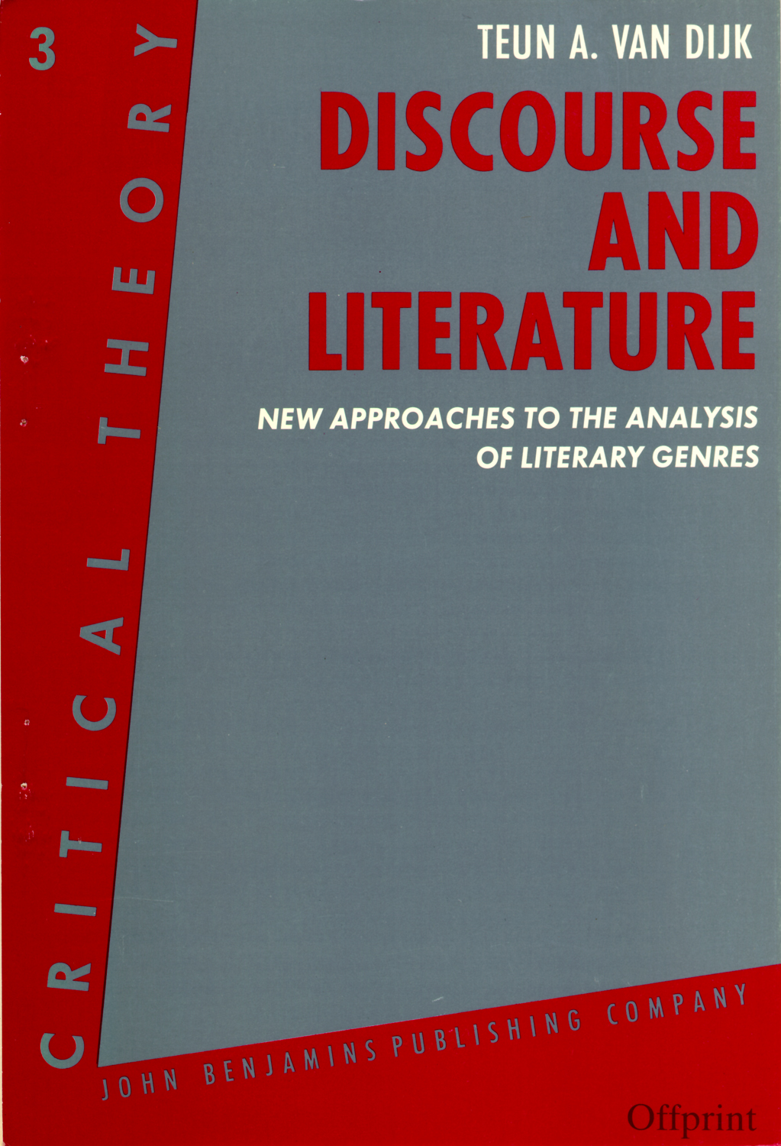

Un article publié dans l'ouvrage sous la direction de Teun A. van Dijk (ed.) intitulé : Discourse and Literature. New approaches to the Analysis of Literary Genres, pp. 187-197. Amsterdam / Philadelphia ; John Benjamins Publishing Co., 1985. Collection : Critical Theory Series, vol. 3.

Note pour la version numérique : La numérotation entre crochets [] correspond à la pagination, en début de page, de l'édition d'origine numérisée. JMT.

Par exemple, [1] correspond au début de la page 1 de l’édition papier numérisée.

[]

Pierre Maranda
Anthropologie, retraité de l’enseignement, Université Laval

“Myths: theologies and theoretical physics.”

Un article publié dans l'ouvrage sous la direction de Teun A. van Dijk (ed.) intitulé : Discourse and Literature. New approaches to the Analysis of Literary Genres, pp. 187-197. Amsterdam / Philadelphia ; John Benjamins Publishing Co., 1985. Collection : Critical Theory Series, vol. 3.

1. Definition of Myth

Myth is an oral or written dramatic narrative pertaining to the semiotic foundations of a society. It is thus an implicit actualization of a meaning-building matrix ; as such, it underlies many other genres ; it is a manifestation of (and therefore a means of access to) ideologies ; it generates all sorts of semiotic discourses in art, politics, literature, rituals, games, science, etc. In effect, "myths display the structured, predominantly culture-specific, and shared semantic systems which enable the members of a culture area to understand each other", to live together through inertia and innovation, and to think and dream themselves out to themselves. Myth, through art, science, technology and other semiogenetic operators, is a survival mechanism that makes it possible for human groups to perpetuate themselves. More specifically, "myths are stylistically definable discourses that express the strong components of semantic systems" (Maranda 1972b ; 12-13).
The preceding definition consists of two vectors ; a formal one ("stylistically definable discourses") and one related to contents ("express the strong components of semantic systems"). However, those two components merge because myths as discourses derive their styles from their messages. The information they convey is necessarily related to basic structures of a sermiotic system (see next section, Boas's quote). This means that they will mainly deal with more or less random events that they will try to reduce to a pattern consistent with cultural interpretative models. In such operations, they will work out as a logical (dialectic) machine to explore acute contradictions, reduce their impacts, and resorb them, or shelve them as unsolvable (Lévi-Strauss 1958. Ch. 11). Myths, therefore, are semiogenetic devices operating at the very core of all cognitive processes.
[188]

2. Theoretical Aspects

Boas and Lévi-Strauss as well have proposed a theory of myth at the level of what is sometimes called "deep structures". Two quotations will make this clear.

"To draw a parallel... between this ethnological phenomenon [modesty] and linguistic phenomena, it would seem that the common feature of both is the grouping together of a considerable number of activities under the form of a single idea, without the necessity of this idea itself entering into consciousness... I believe that the unconscious formation of these categories is one of the fundamental traits of ethnic life, and that it even manifests itself in many of its more complex aspects ; that many of our religious views and activities, of our ethnical concepts, and even our scientific views, which are apparently based entirely on conscious reasoning, are affected by this tendency of distinct activities to associate themselves under the influence of strong emotions. It has been recognized before that this is one of the fundamental causes of error and of the diversity of opinions" (Boas 1911 : 58-59).

Actually, Hubert & Mauss (1897-1889, 1902-1903) had already emphasized, after Frazer, the paramount importance of associative structures in the constitution of the strong components of semantic systems (for their three laws, see Mauss 1960 : 57-67). Whenever need be, such components as "modesty", "fear", "anger", etc., are linked up into a discursive syntagm that will attempt to interpret, through reorganization of cultural stocks, and to face up to, conjonctural challenges. In this respect, science and mythology proceed similarly ; both revamp the "capital" already "owned" and "coined" by a given society in order to render amenable to new managements the stocks stored in the collective memory of the group (be it the minds of the elders or libraries). "The kind of logic in mythical thought is as rigourous as that of modern science, and... the difference lies, not in the quality of the intellectual process, but in the nature of the things to which it is applied" (Lévi-Strauss 1964 ; 230).
The processes of mythical thought may appear confused because the method we use to approach them is confusing. After Hubert & Mauss, Lévi-Strauss is doubtless the one who, beyond other analysts like Euemeros in Classical Greece, Montaigne, the Grimm brothers, Cassirer, Müller, Frazer, Jung, Campbell, Ranke, Propp, Jensen, Eliade, and many others, has done most to rid our approaches to myth from its traditional fuzziness.
[189]

3. Methods of Analysis

This is not the place for a review of diverse methods of myth analysis (see the 13 chapters of Maranda 1972b to this effect). All analysts have actually strived to reduce the apparently overwhelming complexity of myths to basic patterns. All have tried to contain their seeming exuberance into analytic frameworks which, since Propp, rest on a set of descriptive functions,

"The world of symbolism is infinitely varied in contents but always limited in its laws... A compilation of known myths and tales would fill an imposing number of volumes. But they can be reduced to a small number of simple types if we abstract, from among the diversity of characters, a few elementary functions" (Lévi-Strauss 1964 : 203-204).

Many students of myths have come up with futile or sterile theories because they focused on contents instead of on structure. Their interpretations lead to views of myths reduced to themes or features (Köngäs Maranda 1973). Be it solar mythology, Freudian ethnocentricism, or the type/motif indexes of folklorists, contents-based approaches turn out to be as opaque as the data they aim at clarifying. By contrast, structural analysis leads to "X-raying" semiotic data. For example, Lévi-Strauss' classical analysis of Oedipus (1958 ; Ch. 11) reaches a deeper level of explanation than Freud's (cf. Maranda 1978).
The remainder of this chapter will present a concise "pocket guide" to the structural analysis of myths (and of other semiotic data). It consists of four parts : (1) identifying contrasts ; (2) analyzing their arrangements ; (3) investigating mediation processes ; and (4) mapping out the overall structure.

STEP 1: CONTRAST IDENTIFICATION

This step is a paradigmatic analysis on which rests all the procedure. It is essentially emic ; it aims at mapping out, according to culture-specific categories, the semiogenetic axes/vectors -at work in a text (broadly defined here, à la Lotman and Soviet semiotics). Then, are those vectors in contrast (emically, of course), and if so, how ? Throughout this step one must draw on ethno-semantic protocols like Turner's (1971), Black's (1969) or on the exploration of connotative meaning through protocols like WAT-PAT (Word Association Tests paired to Plot Association Tests) (Maranda 1972a ; cf. Johnson 1975, Szalay & Deese 1978). The analyst will then be in a position to define which semantic operators are effective in a given text, on what dimensions they operate, and how they lay the grounds for a (dialectic) dynamism becoming manifest in syntagmatic structures (cf. Ldvi-Strauss 1962 ; 197-198, 1964 ; 313, 1966 ; 305, 1968 ; 155, 1973 ; Ch. 7 ; Meletinsky et al. 1974 ; Maranda 1981a, b).

[190]
Here, a semiographic cube (Maranda & Köngäs Maranda 1971 ; 21-22) may be used as a device to plot both the elementary basic contrasts of a text and their dynamisms. Each corner of the cube stands for a combination of three dimensions e.g., sex (male-female), age (young-old), status (high-low), cosmologic (heavenly-chtonian), social/physical distance (far-near), cosmological status (human-divine), cuisine (raw--cooked, boiled--roasted), contents (inside-outside), etc.
Thus, to represent the Christian myth of the Original Sin and of the restoration of mankind to goodness through the operation of Christ, let us first map out the contrasts on the semiographic cube. The three layers define vertical contrasts ; supernatural abstract, supernatural concrete, and human. The left and right ends of the horizontal vertex stand for man and woman, respectively. The depth dimension, for positive (good, immortal) and negative (evil, mortal), viz., Adam and Eve before and after the sin. Dotted lines show possible but missing contrasts within this cultural system (viz., female deities and devils).

[191]

Figure 1.
The Semiographic Cube of Genesis Ch. 3
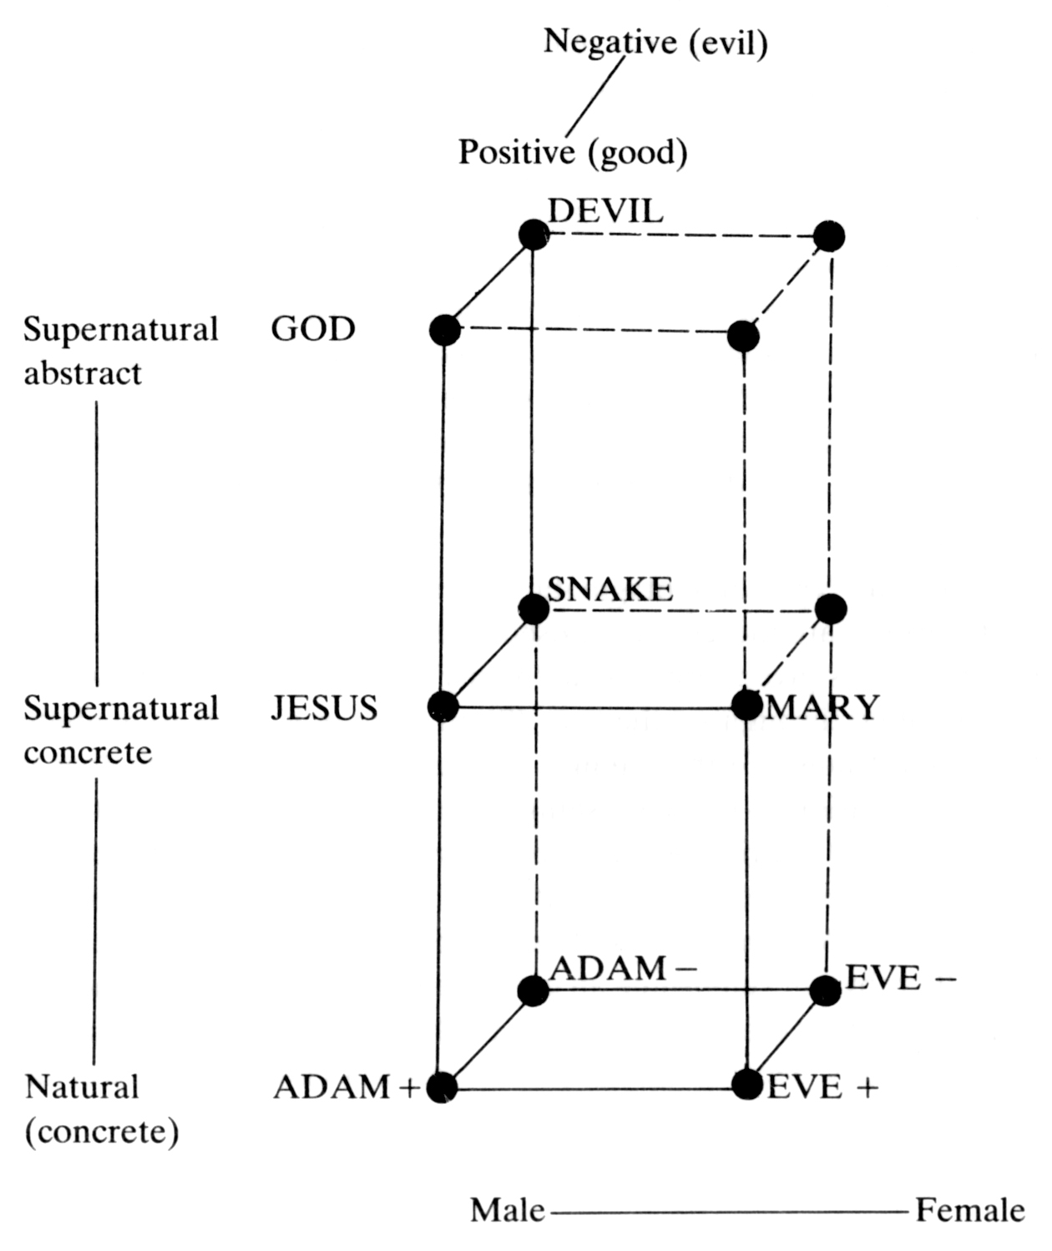

STEP 2 : CONTRAST ARRANGEMENTS

There are several types of contrasts ; antonyms, oppositions, contradictions, etc. (cf. Greimas' "semiotic square" and its reformulation in terms of Thom's "catastrophe theory" by Petitot 1977). Furthermore, their arrangements vary from culture to culture and, within specific semiotic universes, from types to types of texts. The main arrangements are listings, juxtapositions, embeddings (both simple and multiple), embeddings with/without [192] contrast, etc. All are best described with the help of network theory (Maranda 1976, 1981b ; Maranda and K6ngds Maranda 1980).
Contrast outlays are significant and generally follow Hubert & Mauss' three association laws. For example, God creates Adam by a manipulation of clay (law of contiguity) and Eve through a metonymic process (Adam's rib, again law of contiguity). At the same time, man is made in God's image (law of similarity) but he is subject to God (homology by reduction - cf. Maranda 1980). This contrast will be developed into an opposition (Hubert & Mauss' third law) when the Devil comes up. His seduction of Eve is done through contiguity (co-presence and fruit) when he proposes to her to "become like God" (law of similarity), which process eventually brings about the origin of death (law of opposition by inversion ; life ⁻¹ = death). And Christ's redemption will be an inversion of this inversion (on this double inversion mechanism, see Maranda & K6ngAs Maranda 1971 ; 24-28).

STEP 3 : MEDIATIONS

There are four types of syntagmatic structures in which contrasts are found. (1) Contrasts are merely juxtaposed without any attempt to mediate them : the situation is given either as a "happy" or "unhappy" state which will not be modified throughout the text ; (2) an attempt is made to mediate the contrasts but it fails ; (3) the attempt succeeds ; and (4) not only does it succeed but, in addition to re-establishing an equilibrium (cf. the First Law of Thermodynamics, the principle of the conservation of matter and energy), it brings about some additional profit ; the "capitalist transformation" (Maranda & Köngäs Maranda 1971) ; thus, not only does the lowly hero save the princess, thereby re-establishing an equilibrium (Model 3) but his heroic deeds bring about a new era of prosperity to the kingdom (and to the princess since she will usually become the mother of several children and will be forever happy afterwards).
[193]

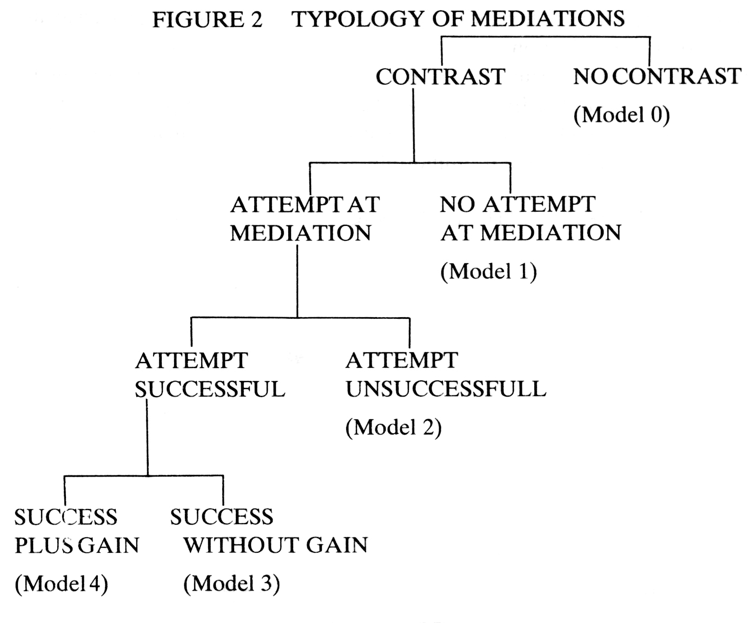

If the Devil won the first round — his astuteness was the mediating factor of his triumph over God — the game is not over. God will counterattack by taking a visible shape himself, as did the Devil. The latter took the semblance of a snake (law of similarity), God will take that - nay, the very nature — of man. (After God had made man in his image, he will himself become his own image, and to the extent that he seemingly vacates his own substance — like a snake his skin ? — to perilously take abode in his human reflection. This would be surely a great risk and a case of the boldest metaphysical nihilism were it not for that, through the concept of the Trinity, mankind learned that God never really abolished metaphysics because he had kept one, or even two, of himself safely in reserve and had only sent his son to in-carnate himself in the skin of a male God-image.)
But will this attempt at mediation succeed ? Will redeemed mankind be as good and as new as it was in the Garden of Eden ? Will that operation be a Model 3 (successful mediation), or did it fail ? Believers and theologians preach that, actually, we have here a Model 4 : Felix Culpa ! because, now, mankind is surely better off than it would have been had it stayed in the [194] state of original bliss, for it knows that God loved it enough to give away his only son for its salvation. Indeed, replied the Humanists of the Renaissance, inverting the argument. Thanks to our mother Eve, who had the courage of her eagerness to know, we are now mortal but knowledgeable instead of having remained, as Adam and God would have had it, immortally ignorant.

Figure 3.
THE DYNAMICS OF GENESIS CH. 3
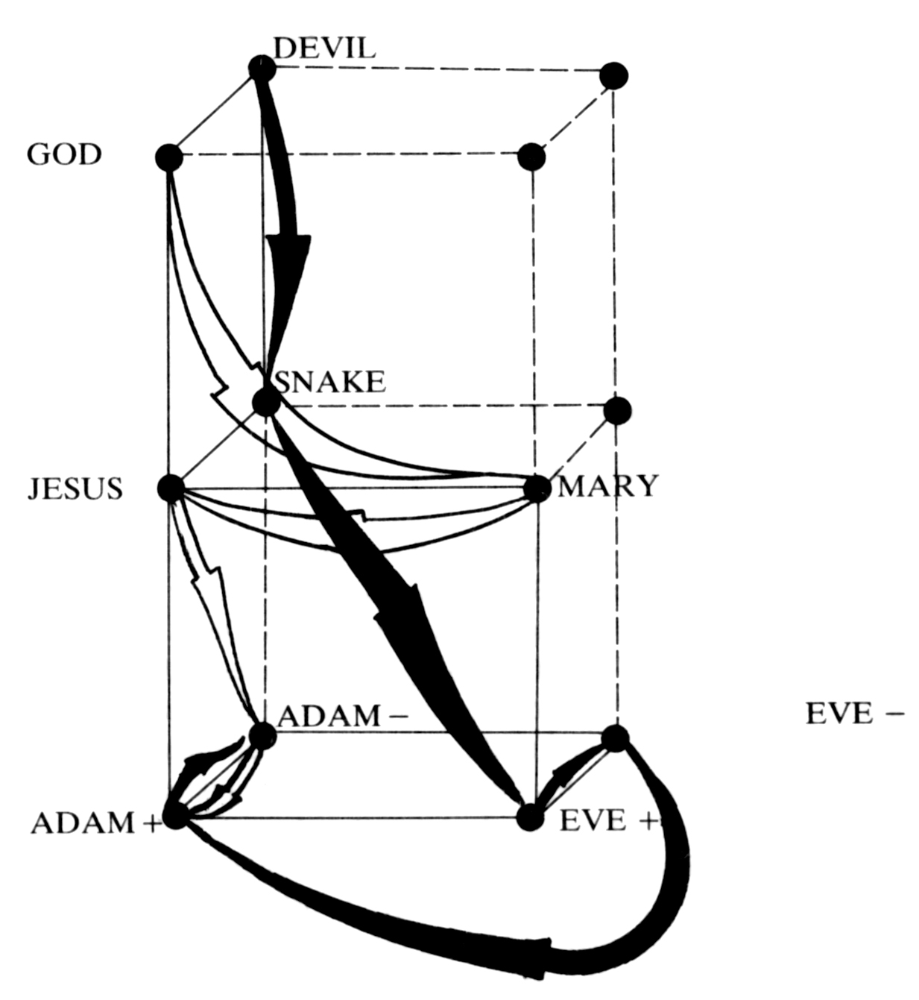
No myth can be interpreted outside of its intertextuality, i.e., of the set of all its known variants (Lévi-Strauss 1958 ; Ch. 11, much before Kristeva popularized the same principle). But what are the border of variants ? For example, are Cinderella (Type 510A) and The Dress of Gold, of Silver, and of Stars (Type 510B) different folktales or do they belong to the same struc

[195]
ture (cf. Maranda 1973) ? Is Lévi-Strauss' canonical formula (1958 : Ch: 11 ; 1974) a valid measure of semiotic boundaries ? Space does not permit elaboration in this context (for developments, see Maranda 1977). Let us return to the case of the Original Sin, which can be seen as pertaining to the same intertext structure as the laws of thermodynamics (Maranda 1972c).
Our reading of Genesis Ch. 3 leads to an interpretation of this Western myth as a conflict of entropic and negentropic operations, which is a rereading of it by recoding it through operators of theoretical physics. First, we have a conflict of incarnations or of "concretisations" : will evil remain more concrete than good ? and death than immortality ? Immortal Devil takes the initiative by becoming an (immortal) snake ; immortal God follows and becomes a mortal man who dies, having been the bait to lure the agent of death, the Devil, in killing death by killing a false image of man (who is the true image of God) so that death should not prevail any more (but this will be only "abstract" or "invisible" death). However, the Devil killed only a semblance of God at the same time as only a semblance of man (law of similarity) because God had only apparently left his own substance. Therefore "death" is not dead and it continues to occur as the outcome of human life despite efforts to emphasize the contrary (on the level of eternal life). Paradise is still lost and its reinvention as an after-death reality in no way restores visible immortality to mankind. People have no other choice, then, than to state that despite the statement of the First Law of Thermodynamics (an optimist axiom of equilibrium), the Second Law (entropy) prevails.

4. Conclusion

This brief review of an approach to the analysis of myths as discourses could but highlight a few tacks proposed in structural semiotics. Like myth analysis, discourse analysis is itself a mythic process. As Eve in the Garden of Eden, we will want to eat from all the trees of knowledge, but we will always transform their fruits into our own kind of mental flesh.

BIO-BIBLIOGRAPHICAL NOTE

Pierre Maranda is professor of anthropology, Universit6 Laval, Qu6bec, Canada, G1K 7P4. After studying Literature (M.A., Montréal) and philosophy (L. Ph., Montréal), he got his Ph. D. at Harvard University, where he also served as instructor, researcher and Fellow of the Peabody Museum in Oceanic anthropology. He did field work in Malaita, Solomon Islands. He has been visiting professor at École des Hautes Etudes en sciences sociales (Paris), Collège de France (Paris), Universitade federal do Rio de Janeiro, etc. Among his numerous publications dealing [196] with sociosemiotics ; Structural Models in Folklore and Transformational Essays (2^{d} ed. 1970, Mouton ; with Elli Köngäs Maranda) ; French Kinship ; Structure and History (Mouton 1974) ; L'Imaginaire québécois ; La Dévolution tranquille (Montréal, in press) ; ongoing work with computer-simulation models and generation of artificial metaphors used in the field to test semiogenetic hypotheses.

REFERENCE

Black, M. 1969. "Eliciting Folk Taxonomies in Ojibwa," In S. Tyler, ed. Cognitive Anthropology, pp. 165-189. New York ; Holt, Rinehart & Winston.
Boas, F. 1911. "Introduction," In Handbook of American Indian Languages, Bulletin 40, Part I, Washington : Bureau of American Ethnology.
Hubert, H. et M. Mauss. 1897-1898. Essai sur la nature et la fonction du sacrifice. Année sociologique, 2.
https://classiques.uqam.ca/classiques/mauss_marcel/melanges_hist_religions/t2_sacrifice/sacrifice.html
_____, 1902-1903. "Esquisse d'une théorie générale de la magie." Année sociologique, 4 (reprinted in Mauss 1960).
https://classiques.uqam.ca/classiques/mauss_marcel/socio_et_anthropo/1_esquisse_magie/esquisse_magie.html
Köngäs Maranda, E.K. 1973. "Five Interpretations of a Melanesian Myth." Journal of American Folklore 86 : 3-13.
Johnson, E.R. 1975. "Meaning in Complex Learning." Review of Educational Research 45 : 425-459.
Lévi-Strauss, C. 1958. Anthropologie structurale, Paris : Plon.
_____, 1962. La Pensée sauvage, Paris : Plon.
_____, 1964. Mythologiques* Le Cru et le cuit, Paris : Plon.
_____, 1966. Mythologiques" Du Miel aux cendres, Paris : Plon.
_____, 1968. Mythologiques` L'Origine des manières de table, Paris : Plon.
_____, 1971. Mythologiques* LHomme nu, Paris : Plon.
_____, 1973. Anthropologie structurale deux, Paris ; Plon.
_____, 1974. La Voie des masques, 2 vols. Paris : Skira.
Maranda, P. 1972a. Introduction to Anthropology ; A Self-Guide, Englewood Cliffs, N.J. ; Prentice-Hall.
_____, 1972b. "Introduction." In Id., ed., Mythology, Penguin Books.
_____, 1972c. "Structuralism in Cultural Anthropology." In 1972 Annual Review of Anthropology, pp. 329-348. Palo Alto, California ; Annual Reviews Inc.
_____, 1973. Cendrillon ; "Théorie des graphes et des ensembles.' In Chabrol, C., ed., Sémiotique narrative et textuelle, pp. 122-136. Paris ; Larousse.
_____, 1976. "Informatique, simulation et grammaires ethnologiques." Informatique [197] et sciences humaines, 28 ; 15-30.
_____, 1977. "Cartographie sémantique et folklore ; Le Diable beau danseur à Rimouski." Recherches sociographiques, 18 : 247-270.
_____, 1978. Review of Brisson, L., Le Mythe de Tirésias : essai d'analyse structurale, Man, 13 : 328-329.
_____, 1980. "The Dialectic of Metaphor ; An Anthropological Essay on Hermeneutics." In Suleiman, S.R. & Crosman, 1, eds., The Reader in the Text ; Essays on Audience and Interpretation, pp. 183-204. Princeton N.J. 1 Princeton University Press.
_____, 1981a. "Cartographie sémantique ; esquisse sémiographique de la Québécoise." Cahiers de Géographie du Québec, 25 : 71-86.
_____, 1981b. "Elementary Text Structures ; Experimental Semiography." In Petõfi, J.S., ed., Text vs. Sentence, pp. 159-176. Hamburg : Helmut Buske Verlag..
Maranda, P. & E.K. Köngäs Maranda. 1971. "Structural Models in Folklore." In Köngäs Maranda, E.K. & Maranda, P., Stuctural Models in Folklore and Transformational Essays, pp. 16-94. Paris/The Hague : Mouton.
Maranda, P. & E.K. K6ngds Maranda. 1980. "Myth As a Cognitive Map ; A Sketch of the Okanagan Myth Automaton." In Burghardt, W. & K. Hölker., eds., Text Processing / Textverarbeitung, pp. 253-272. Berlin : de Gruyter.
Mauss, M. 1960. Sociologie et anthropologie, Paris ; Presses Universitaires de France.
https://classiques.uqam.ca/classiques/mauss_marcel/socio_et_anthropo/socio_et_anthropo_tdm.html
Meletinsky, E., S. Nekludov., E. Novik., & D. Segal. 1974. "Problems of the Structural Analysis of Fairytales." In P. Maranda. ed., Soviet Structural Folkloristics, pp. 73-142. Paris-The Hague : Mouton.
Petitot, J. 1977. Topologie du carré sémiotique, Études littéraires (Québec, Université Laval), 10, 347-428.
Szalay, L.B. & J. Deese. 1978. Subjective Meaning and Culture, Hillsdale, N.J. : Erlbaum.
Turner, V. 1971. "The Syntax of Symbolism in a Ndembu Ritual." In P. Maranda & E.K. Köngäs Maranda., eds., Structural Analysis of Oral Tradition, pp. 125-138. Philadelphia : University of Pennsylvania Press.

Fin du texte

